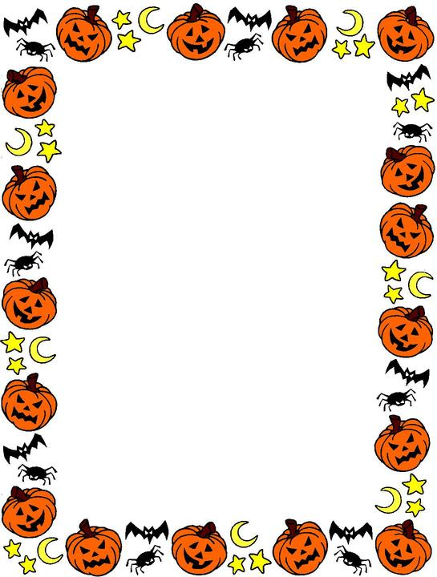

**Monday 31st October**

**Millbrook Methodist Church Hall**

**6-8pm**

Torpoint and Rame Youth Project would like to invite you to our Halloween Party…

Snacks

Spooky Music Quiz

Board games, Wii, Table Tennis

**Calling All Year 7-10s**

**Your text here**